|  |  |  |  |
| --- | --- | --- | --- |
| \\lyng-dc1\StaffShared\Learning Bugs Animals ALL subjects\characters bugs animals\Cyril the Snail - History.jpeg**Lyng Primary School Knowledge Organiser** | | | |
| **History Topic: Stone Age** | **How did civilisations change from Stone Age to Iron Age?** | Year 5  *Civilisation and Communication* | Autumn 1 |

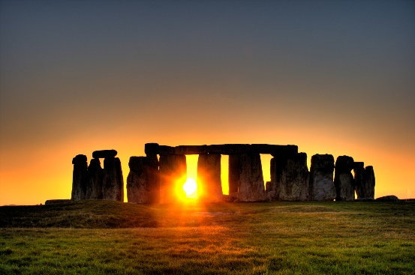

**Background information for parents and teachers**

A civilization is an advanced society with farming, division of labour, multiple cities, organized religion, science/technology, some form of government, and a written language. The main factor that allowed civilization to develop was farming. Humans were forced to live in one place and farming also provided enough food to support large numbers of people.

|  |  |
| --- | --- |
| **What Step On and Goldilocks words will I use?** | |
| **Spelling** | **Definition** |
| Slaughter | Kill for food |
| Orphan | Child without parents |
| Ancient | Very old |
| Civilisation | The level of development at which people live together peacefully in communities |
| Fossil | The preserved remains of plants or animals |
| Agriculture | Farming |
| Hunter-Gatherer | A person who meets their needs by hunting animals and gathering plants |
| Palaeolithic era | The earliest part of the Stone Age characterised by making tools of crudely chipped stone and by cave art |
| Mesolithic era | The period between the Upper Paleolithic and the Neolithic eras. Characterised by advancements in tools to allow for leather work and basketry, domesticating animals and plans. |
| Neolithic era | The last period of the Stone Age when humans began to develop agriculture and use tools and weapons |
| Winter Solstice | Shortest day of the year |
| Summer Solstice | Longest day of the year |
| Flint | A type of stone that can be shaped into blades, knives and spears for hunting. |
| Tribes | A group of people that live together for protection |
| BC | Before Christ A date such as 3000 BC means 3000 years before the year 1 AD (No 0 AD) |
| AD | Anno Domini in Latin which stands for ‘in the year of our Lord.’ A date such as 2019 AD means 2019 year after Jesus is believed to have been born. |

|  |  |
| --- | --- |
| **When? (Timeline of key events)** | |
| 814000 BCE | Evidence of flints made into tools in Britain. |
| 40000 BCE | Homo Sapiens arrived in Britain. |
| 33000 BCE | Ice Age drove humans out of Britain. |
| 11,000 BCE | Humans returned to Britain. |
| 6500 BCE | Doggerland flooded, forming the English Channel, cutting off Britain from the rest of Europe |
| 4400 BCE | People began to settle across Britain, building farms |
| 3180 BCE | Skara Brae village was built in the Orkney Islands, Scotland |
| 2200 BCE | Bronze Age began in Britain |
| 2000 BCE | Stonehenge was completed and stone walls built. |
| 800 BCE | The Iron Age began |
| 100 BCE | Coins were used for the first time in Britain |
| 55 BCE | Britons in war chariots defeated the Romans |
| 43AD | The Romans invaded Britain again and the Iron Age ended |

**Hook**

**Outback2Basics.**

**Making fat lamps.**

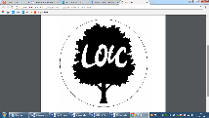

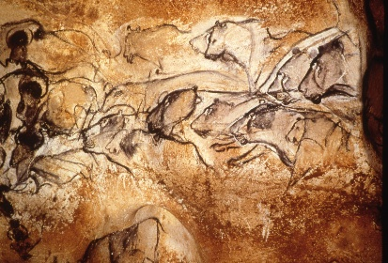



**Charles Darwin** – “It is not the strongest of the species that survives, not the most intelligent that survives, It is the one that is the most adaptable to change.

**Great Quotes**

**TRIP/VISITOR**

**Outback2Basics Natural Paints and Cave art.**

**Our Storytelling Approach to enhance engagement**

|  |  |  |
| --- | --- | --- |
| **People:**  Time traveller | **Place:**  Stone Age forest | **Problem:**  Evil bear on the rampage |

**Focus Text**

**Key Facts and Famous Figures**

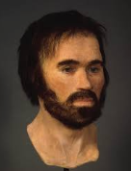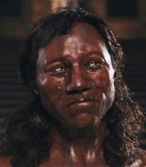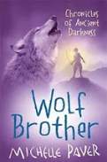  
  
Cheddar Man lived around 10,000 years ago and is the oldest almost complete skeleton of our species, Homo sapiens, ever found in Britain. He was a Mesolithic hunter-gatherer (fully modern human) with dark skin and blue eyes. He was about 166 centimetres tall and died in his twenties. His skeleton was uncovered in 1903 during improvements to drainage for Gough's Cave, a popular tourist attraction.

Lindow Man is a well-preserved human body found in a peat-bog at Lindow Moss, near Manchester, in 1984. He died a violent death, sustaining many injuries before being placed face down in a pool in the bog.

**Key skills – Sequence of Learning**

What was the chronology of the Stone Age?

What was everyday life like in the Stone Age?

How has the climate changed?

How could we find out how Tollund man died?

What was positive about living in the Stone Age?

Use

|  |  |  |  |
| --- | --- | --- | --- |
| \\lyng-dc1\StaffShared\Learning Bugs Animals ALL subjects\characters bugs animals\Cyril the Snail - History.jpeg**Lyng Primary School Knowledge Organiser** | | | |
| **History Topic:** | **How did civilisations change from Stone Age to Iron Age?** | Year 5  *Civilisation and Communication* | Autumn Term |

|  |
| --- |
| Put these three eras of the stone age in order, starting with the oldest:  Neolithic Palaeolithic Mesolithic |
| Start: |
| End:   |  |  |  | | --- | --- | --- | | Where was the Lindow Man found? | **S** | **E** | | 1. In a cave |  |  | | 1. In a river |  |  | | 1. In a grave |  |  | | 1. In a peat bog |  |  |  |  |  |  | | --- | --- | --- | | What was true about life in Britain during the Neolithic era? | **S** | **E** | | Humans lived in caves |  |  | | Homes were made of stone. |  |  | | Humans used tools made from metal. |  |  | | Humans began farming. |  |  |  |  |  | | --- | --- | | How long ago did the Palaeolithic era last? | | | Start | End |  |  |  | | --- | --- | | Evidence suggests that Homo sapiens first migrated from which continent? | | | Start | End | |

|  |  |  |
| --- | --- | --- |
| What was Stonehenge used for? (tick all that apply) | **S** | **E** |
| 1. Ceremonial site |  |  |
| 1. To live in. |  |  |
| 1. Religious pilgrimage destination. |  |  |
| 1. Burial site |  |  |
| 1. Astronomical calendar |  |  |

|  |
| --- |
| What is the name of the cave where the Cheddar man was found? |
| Start: |
| End:  Gough’s cave |

|  |  |  |
| --- | --- | --- |
| Somebody who studies the past by exploring old ruins is called... | **S** | **E** |
| 1. Archaeologist |  |  |
| 1. Settler |  |  |
| 1. Invader |  |  |
| 1. Egyptologist |  |  |

|  |  |
| --- | --- |
| What are megaliths? | |
| Start | End  Large stone monument |

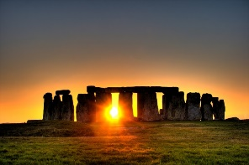

**Stone Age Quiz**

**Start:**

**End:**

|  |  |  |
| --- | --- | --- |
| What was the Cambrian Explosion | **S** | **E** |
| 1. Volcanic explosion. |  |  |
| b) When many animal phyla first appeared. |  |  |
| 1. Pre-historic landslide. |  |  |
| 1. Pre-historic avalanche |  |  |